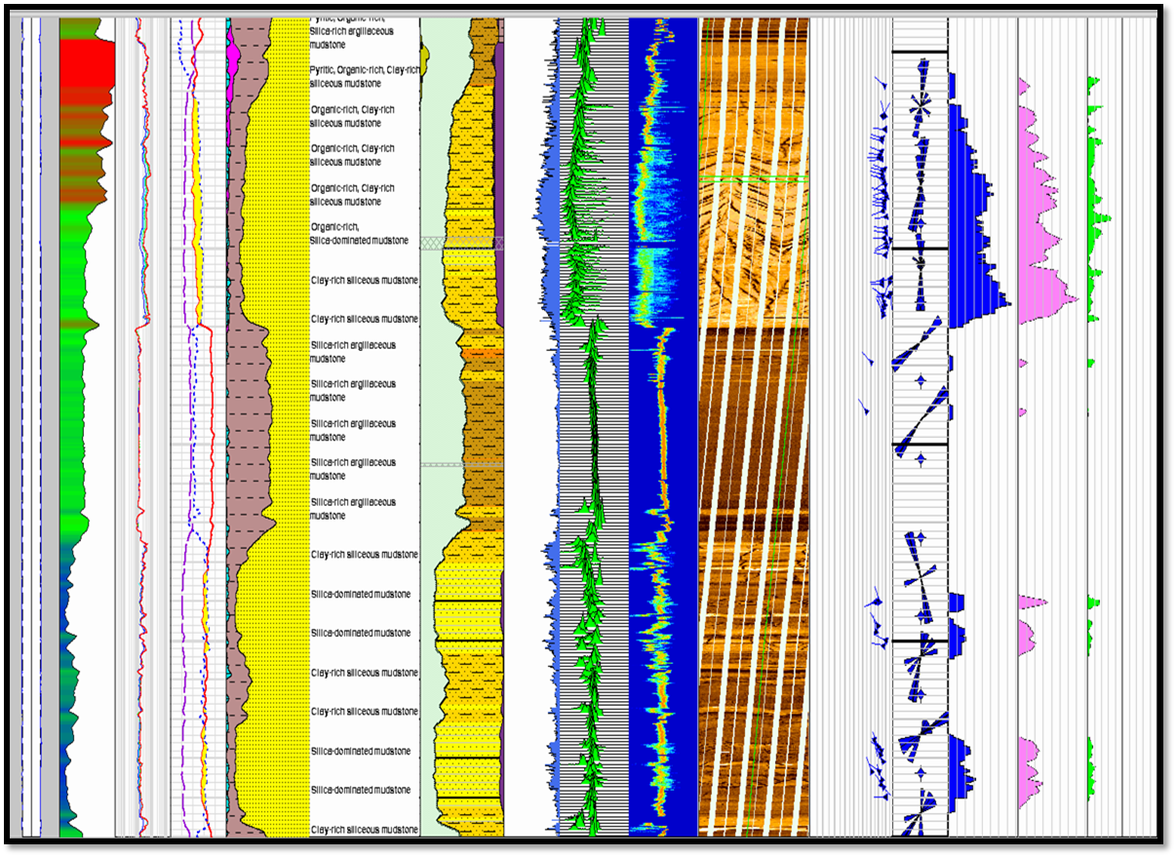

**Petrophysical Services**

**Introduction**

**ROCKSERV** experienced Petrophysicits and industry leading technologies help you collect, interpret, and apply formation evaluation data to locate the optimal formation target either for single well or multi well projects, which include:

* Integration of open-hole logging data with conventional (CCA) and providing special core analysis (SCAL).
* Deterministic and probabilistic petrophysical approaches.
* Common, dominant reservoir models include mineral modeling, porosity modeling, water saturation modeling, TOC modeling, permeability modeling and rock type modeling.
* Identification of flow units and flow barriers / baffles, characterize petrophysical properties of each flow unit, fluid saturation height / fluid contacts and flow unit versus facies relationships.

#### Borehole Imaging

As the borehole image is one of the most important logging tools in terms of high resolution formation details and reservoir geological attributes.

Rockserv is now introducing a full suite of Borehole Image Services that includes:

– Data Orientation QC  
– Data Processing  
– Interactive Dip Picking  
– Paleocurrent Analysis  
– Fracture characterization  
– InSitu Stresses Analysis  
– ElectroFacies Analysis  
– Sand Count , ThinBed Analysis  
– Structural and Stratigraphic Analysis  
– Depositional Environment Interpretation

#### Log Interpretation

Well logs interpretation services provide an insight into the formations and conditions in the subsurface, aimed primarily at detection and evaluation of possibly productive horizons. Like  
– Determination of saturation  
– Clean formations evaluation  
– Resistivity vs. porosity crossplots  
– Microresistivity vs. porosity crossplots  
– Rwa comparison  
– Resistivity-ratio methods  
– Flushed-zone method  
– Invaded-zone method  
– Quick look interpretation

#### Reservoir Characterization

Reservoir characterization is the process of preparing a quantitative representation of a reservoir using data from a variety of sources and disciplines.

#### Petrophysical Evaluation

Petrophysical evaluation was carried out using empirical correlations to estimate the petrophysical parameters of the reservoirs. Correlations established between desired rock properties and measured physical properties were used to derive rock properties such as porosity, water saturation, permeability, Net to gross etc. These properties were populated on the structural models to show heterogeneity within the reservoirs.

#### SCAL

#### Core log Integration

The primary purpose of core to log data integration is to reduce the uncertainty associated with formation evaluation. In so doing, advantage is taken of both the higher precision of core data and the larger scale of investigation of log data. It is particularly important that when tying logs back to core, the calibration algorithm is as well defined as possible. A basic requirement is the definiton of a common reference depth scale. A second requirement is to reconcile the different vertical resolutions by the depth averaging of core data, the signal enhancement of log data, or both. Essential to this process is the adoption of ‘key intervals’ as control zones for data integration. These procedures can result in a reduced uncertainty, which transmits through to reservoir appraisal through a better petrophysical definition of constituent lithological units.

#### Core Analysis

Routine and special core analyses are among our main services, incorporating options such as invasion studies, computed tomography scanning, capillary pressure, wettability, improved oil recovery solutions and reservoir condition measurements. Geological studies we offer can encompass aspects such as Sedimentological and petrological studies to provide:  
– Textural core analysis and integration with the geologic framework.  
– Determination and evaluation of porosity.  
– Petrophysical rock types and water saturation.  
– Applied capillary pressure and calibrating water saturation.  
– Reservoir facies characterization.  
– Pore geometry, clays, and the relationship to water saturation.  
– Flow units and permeability prediction.

### Why we are different?

* Rockserv have a robust team of well experienced Petrophysists 20+ years, that worked in different reservoir exposures i.e. sandstone reservoirs, carbonate reservoirs, thin bedded sand, fractured reservoirs and Low Resistivity Low Contrast Pay.
* Our team well understands tools physics of any logging operations at component level and can help quality control the acquisition process right from its inception and make cost effective logging programs to suite the reservoir challenges.
* We are assuring high quality products and very competitive prices.